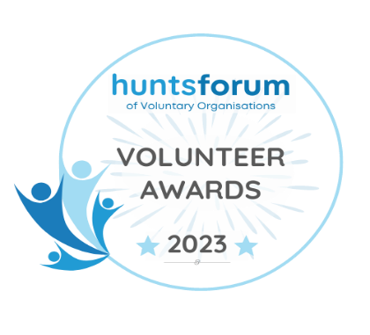
VOLUNTEER AWARD NOMINATION FORM 2023
The volunteer award is your chance to celebrate volunteers and all they contribute to the people and communities they support and is open to all Hunts Forum member organisations.

Please return this form to info@huntsforum.org.uk by 2nd June 2023

Your name:
Your email:
Your contact telephone no:
Hunts Forum Member Organisation:
Volunteer’s Name:
How long has the volunteer been part of your organisation?

Please explain how this volunteer has supported and contributed to the organisation:

Please explain and give examples of how the volunteer has exceeded and gone above and beyond:

Please explain and provide evidence of the impact the volunteer has made on those people or communities they have served:

Please use this space to add any further information or details to support your nomination, please feel free to include links to videos, case studies, articles or anything which will support your nomination:

Please give as much information as possible, we are unable to judge applications that do not give us the information. All forms will be anonymized for judging.

